Approved Minutes
January 22, 2026

Meeting and Attendance: The regular meeting of the Board of Trustees of the Free Public Library of Woodbridge was held at 6:30pm on December 4, 2025, in the BEC Room at the Main Library.
Board members who attended were Ann Dinicola, Isha Vyas, Anthony Terebetsky, Taylor DeLeo, Damarys Cover and Father Smith. Board Attorney Alex Avellan, Library Director Monica Eppinger, Assistant Director Maryann Ralph were also in attendance.

Call to Order: Board President Isha Vyas called the meeting to order at 6:30pm and read the “Adequate Notice of Meeting” statement.

Pledge of Allegiance: Damarys Cover led the Pledge of Allegiance.

Approval of Minutes:

Approval of the Minutes of the Meeting of 10/23/2025 was moved by Taylor DeLeo, seconded by Ann Dinicola. The motion carried.

A roll call was taken for approval:
Ann Dinicola - Aye
Isha Vyas – Aye
Taylor DeLeo – Aye
Father Smith – Aye
Damary Cover – Aye
Anthony Terebetsky - Abstained
The motion carried.

Correspondence: Library Director Monica Eppinger read a letter from the Township of Woodbridge referencing the Standards for Recognizing Board and Commission Members.

Report of the Library Director:

Director’s Report: December 4, 2025
General Operations
- Baker and Taylor, the main provider of print materials for Woodbridge Public Library, will close its doors at the end of December. Ingram, Barnes and Noble and Amazon have already begun to fill orders, but the loss of Baker and Taylor system of filling orders has been felt by libraries nationwide.
- Computers for patrons in the Fords Branch have been upgraded with new, Windows 11 compatible terminals.
- Circulation notices for holds, renewal, automatic renewal, and items overdue are now completely managed by e-mail and text.
- Inventory continues and is closer to completion in the Iselin Branch and Main Library Children’s Department.

FY 2025-26 Fiscal Year State Aid Statistics are available:
WPL State Aid Statistics 2025-2026
Buildings & Grounds
- The ILL Office and Children’s Workroom was painted, and the floor was stripped and waxed.
- Iselin Branch Library has removed a row of high tables with seating and power outlets which were next to the Information Services desk and were not well used. The seating has been relocated to improve the Teen area at the Main Library.
- The upgrade for foot traffic counters in all locations has been ordered to improve the accuracy of the record of visits.
- Restroom improvements for the libraries have begun with Fords and will continue until they have new accessories, they are deep cleaned and repainted.
- Due to a split in a plumbing line, a new faucet and shut off valve were installed in the third floor Board Room.
Community Engagement
- WPL served as a partner in the second annual Central Jersey Book Festival on Saturday, November 15th, 11:am – 3 pm, courtesy of Ross Street School, Woodbridge. The event is administered by the Woodbridge Chamber of Commerce. The event was well run, had an increase in attendance and was highly rated by authors and attendees.
- Librarian Jackie Oakes of the Henry Inman Branch was recognized and given a certificate of appreciation from Ingerman Management for library services provided to the Reinhard Manor seniors in Colonia.
- The Rotary Club expressed gratitude for the public response to the annual coat collection in the libraries.
- The Library has put out a box in all locations to collect unwrapped toys on behalf of the Greenway Family Success Center in Avenel, which serves families and children in the Township of Woodbridge. Partners in the collection include the Avenel Fire Department and Vito Mazza Salon.
- Main Library Digital Help manager Tony Genna organized a Halloween themed art contest again during the last week of October for patrons and staff to vote for their favorites. Library Assistant Jacek Brys received the highest votes for the entry, Colorful Clown. This year the contest was available online and doubled participation to 900 votes.
Report of the Friends of the Library: Nothing to Report

Report of the Board of Trustees President: Board President Isha Vyas thanked Damarys Cover for her time and contributions to the Library Board and wished her well.
Board President Isha Vyas also went over the Library highlights of 2025.

Report of the Board Members:
Board Member Damarys Cover thanked the board for an amazing time she spent as a board member.
Board Member Anthony Terebetsky asked for an update on the lighting situation at the Inman Branch. Assistant Director Maryann Ralph was happy to report that the lighting at the Inman Branch is fixed and working well.
Unfinished Business: None
New Business:

The following Resolution was read by Isha Vyas, moved for approval by Anthony Terebetsky, seconded by Taylor DeLeo, the motion carried.

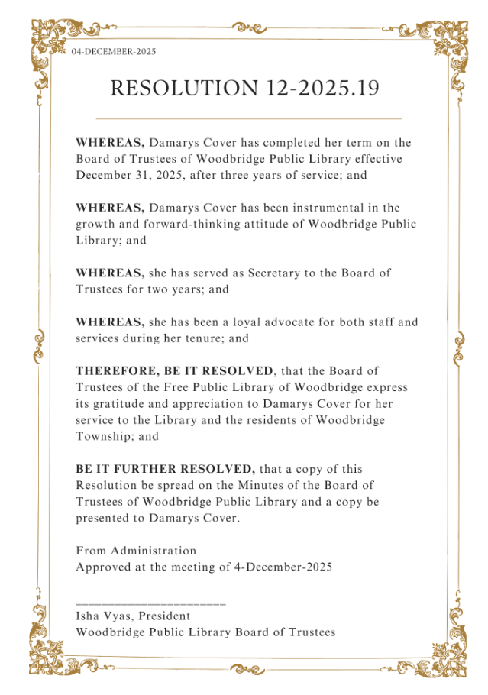

The motion carried.

The following Personnel Report was read by Monica Eppinger, moved for approval by Taylor DeLeo, seconded by Anthony Terebetsky, the motion carried.

Personnel:
PERSONNEL
December 4, 2025

APPOINTMENT
Appoint Raddhi Patel, Library Page, Inman Branch Library, Part time, 6 hours per week, $15.48 per hour, replacing Joe Okoroagu, effective 12/08/2025.
Appoint Sofia Mercado, Library Page, Inman Branch Library, Part time, 6 hours per week, $15.48 per hour, replacing Sofia Vitale, effective 12/01/2025.
PROMOTION
Promote Emily Schindler, Library Assistant, Full Time, 35 hours per week, Main Library, to Senior Library Assistant, Main Library, Full Time, 35 Hours per week, $44,846 annual salary, pending CSC procedures, effective 11/17/2025.

A roll call was taken for approval:
Anthony Terebetsky – Aye
Ann Dinicola - Aye
Isha Vyas – Aye
Father Smith – Aye
Damarys Cover -Aye
Taylor Smith -Aye
The motion carried.

The following Personnel was read by Monica Eppinger, moved for approval by Taylor DeLeo, seconded by Anthony Terebetsky, the motion carried.

PERSONNEL
December 4, 2025

APPOINTMENT
Appoint Raddhi Patel, Library Page, Inman Branch Library, Part time, 6 hours per week, $15.48 per hour, replacing Joe Okoroagu, effective 12/08/2025.
Appoint Sofia Mercado, Library Page, Inman Branch Library, Part time, 6 hours per week, $15.48 per hour, replacing Sofia Vitale, effective 12/01/2025.
PROMOTION
Promote Emily Schindler, Library Assistant, Full Time, 35 hours per week, Main Library, to Senior Library Assistant, Main Library, Full Time, 35 Hours per week, $44,846 annual salary, pending CSC procedures, effective 11/17/2025.
RESIGNATION
Sophia Vitale, Library Page, Part time, Inman Branch, effective 10/31/2025.
Alexandria Burton, Library Page, Part time, Main Library, effective 09/25/2025.

A roll call was taken for approval:
Anthony Terebetsky – Aye
Ann Dinicola - Aye
Isha Vyas – Aye
Father Smith – Aye
Damarys Cover -Aye
Taylor Smith -Aye
The motion carried

Bill Lists: The following Bill Lists were read and moved for approval by Anthony Terebetsky, seconded by Taylor Deleo, the motion carried.

Bill Lists – 12/04/2025
Bill List - 01 $ 104,490.38
Bill List - 02 $ 54,864.73
TOTAL $ 159,355.11

A roll call was taken for approval:
Anthony Terebetsky – Aye
Ann Dinicola - Aye
Isha Vyas – Aye
Father Smith - Aye
Damarys Cover -Aye
Taylor DeLeo -Aye
The motion carried.

Good and Welfare: The Libraries have placed bins to collect unwrapped new toys on behalf of the Greenway Family Services Center of Avenel, NJ which serves children and families of Woodbridge and will match the gifts with their clients this holiday.
Public Comments: None

CLOSED SESSION: None

Adjournment: A motion to adjourn the board meeting was made by Damarys Cover, Ann Dinicola seconded the motion. The meeting was adjourned at 6:50 p.m.

